

**IT5x82**

**Fundamentals of Data Models and Databases**

**Level 5**

**Assignment One**

**Report and Data Models**

**Semester 2 2017**

**Christopher Simmons**

**Table of Content**

Page 3 Intro & Background

Page 4 Un-Normalised Data

Page 5 Normalised Data at 1NF & Normalised Data at 2NF

Page 6 ERD (Entity Relationship Diagram

Page 7 Business Process Model & Use Case Diagram

Page 8 Functional Hierarchy & CRUN Matrix

Page 9 Conclusions & Recommendation

**Intro**

My name is Christopher Simmons I am data base modeller, I have be given the task of modelling a database for Tongariro Garage (2017) Ltd.

**Background**

Tongariro Garage (2017) Ltd is a small independent garage who is wanting to upgrade it’s IT capability by storing some of its information in a SQL Database. At present, their details are stored in a book but this book is not efficient and is not very well ordered. So you will have to arrange a meeting with Client to get information as well as the information provided below:

1. The client would like to store details of their Clients, Vehicles, and Service

2. They would like to keep track of the Clients, Vehicles, and Servicing

3. Add/Update/Delete Records when appropriate

4. Add/Update/Delete Tables where appropriate

5. Do monthly Reports

a. On all Clients, Vehicles and Servicing

b. On specified Clients, Vehicles, and Servicing

Other Details Business

All staff can access the database, add and update details

Only the Admin Can Delete Tables

A customer will become a member of the Garage and fill out a form with their Customer details and Vehicle details.

If they become a regular customer, they will get a 10% discount on work carried out.

A regular customer is one who uses the garage more than 3 times a year.

The form is processed by the Admin person onto the database. The mechanics can add details of servicing done on vehicles.

**Un-Normalised Data**

*Assumption all entities need ID*

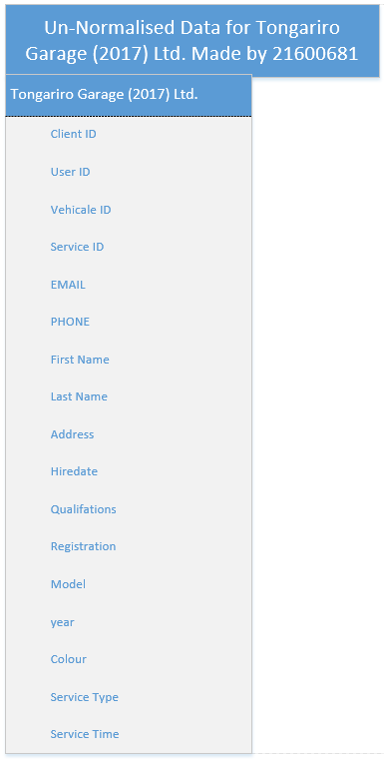

**Normalised Data at 1NF**

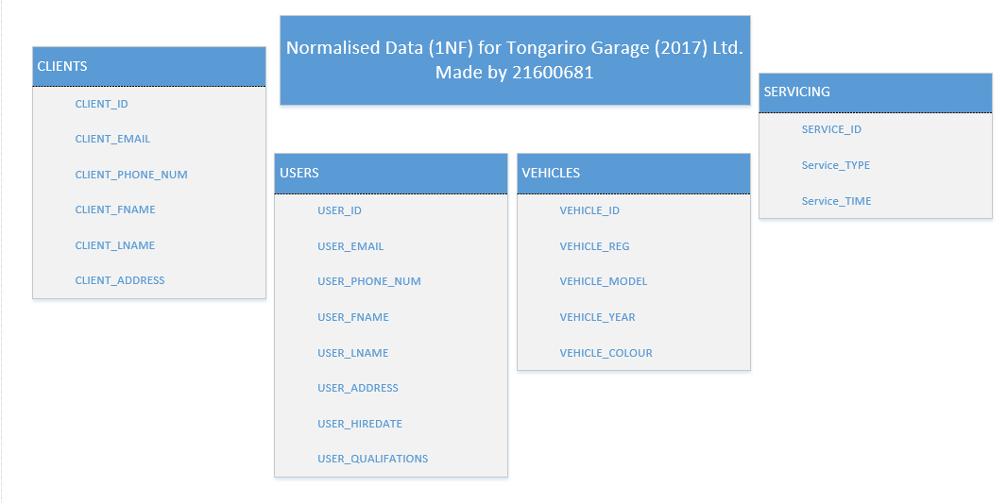

*Assumption Vehicles has table of its own*

**Normalised Data at 2NF**

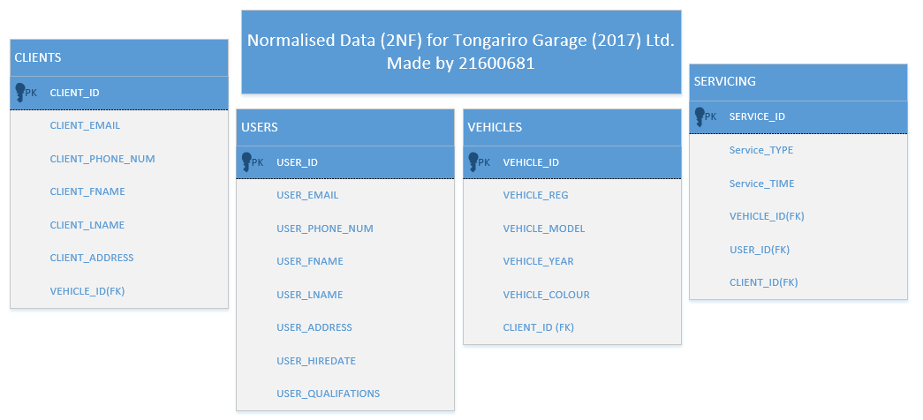

*Assumption Vehicle is connected to Client. Client, users and Vehicles are connected to servicing*

**ERD (Entity Relationship Diagram)**

*Assumption all other Entity’s are connected to Service for they would not be needed without Service*

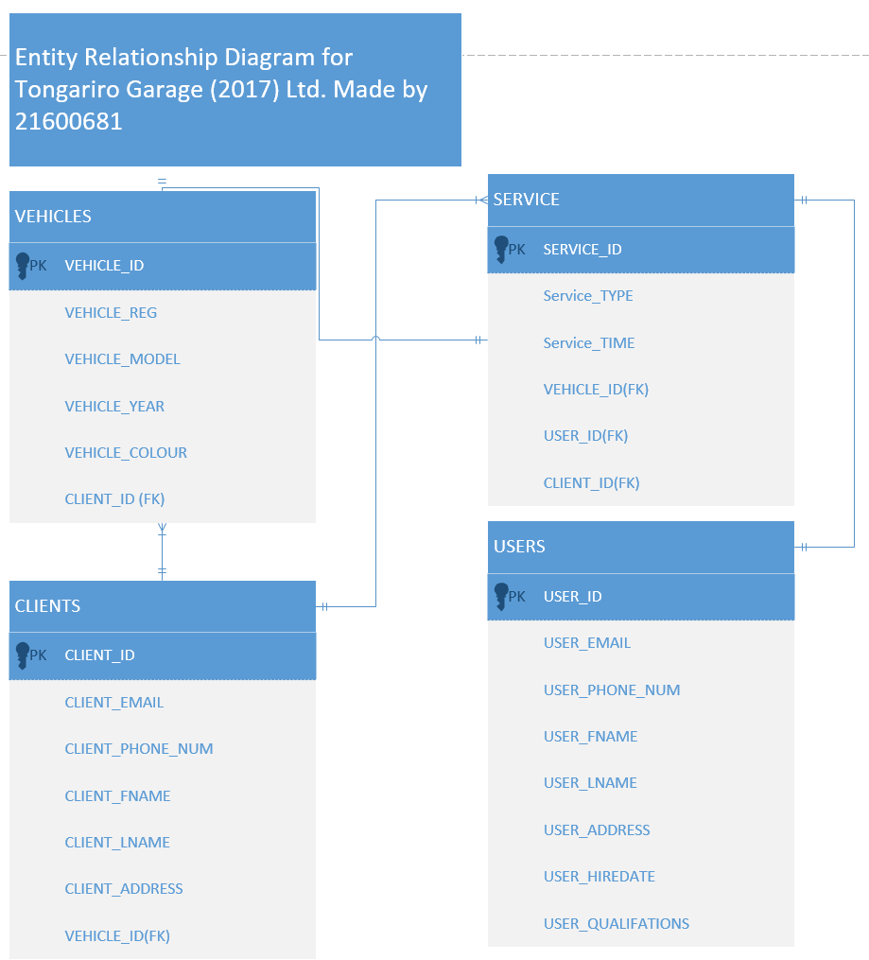

**Business Process Model**

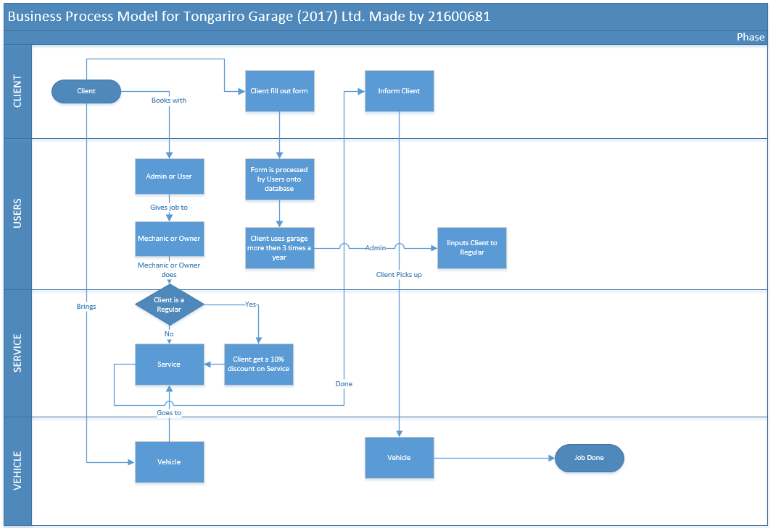

*LTSA is not part of this process*

**Use Case Diagram**

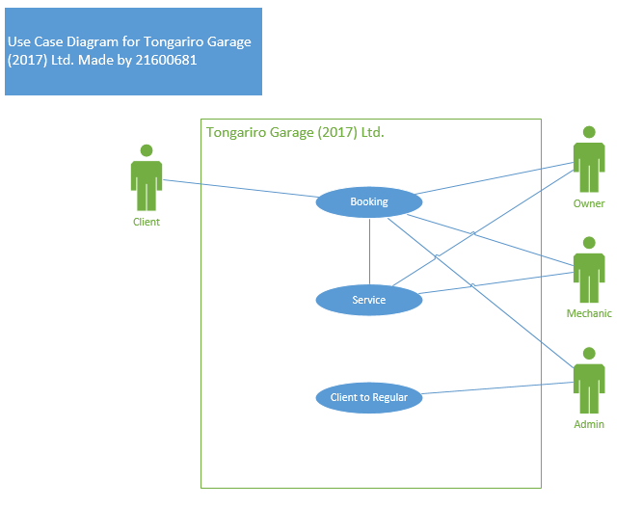

**Functional Hierarchy Diagram**

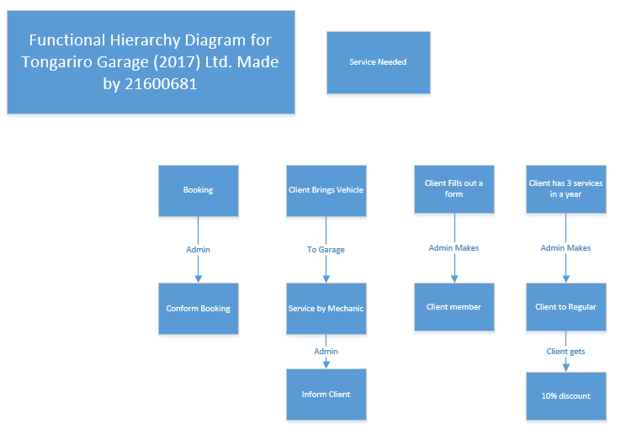

*Assumption Admin makes Client to Regular.*

**CRUD Matrix**

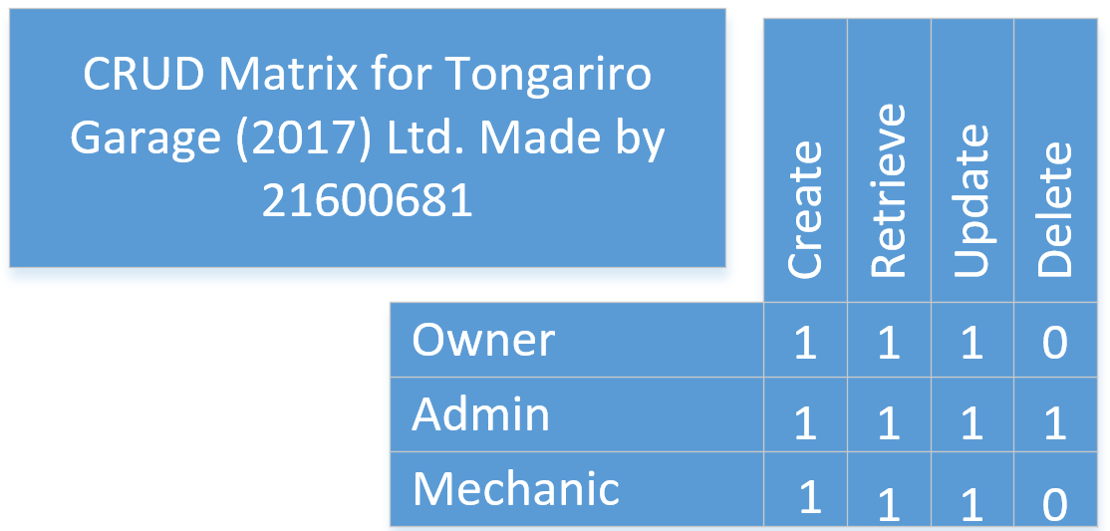

**Conclusion**

Tongariro Garage (2017) Ltd is a small independent garage who is wanting to upgrade it’s IT capability by storing some of its information in a SQL Database

**Un-Normalised Data**

*Assumption all entities need ID*

**Normalised Data at 1NF**

*Assumption Vehicles has table of its own*

**Normalised Data at 2NF**

*Assumption Vehicle is connected to Client. Client, users and Vehicles are connected to servicing*

**ERD (Entity Relationship Diagram)**

*Assumption all other Entity’s are connected to Service for they would not be needed without Service*

**Business Process Model**

*LTSA is not part of this process*

**Functional Hierarchy Diagram**

*Assumption Admin makes Client to Regular.*

**Recommendations**

Hire or teach a admin that knows to use sql.

Place database in a secure location so that unauthorised users cant physically access the database.